horizontal line

**Decathlon**

Lan Song Road NO. 555

PostgreSQL PGPOOL-II Work Manual

**12th August 2019**

|  |  |  |
| --- | --- | --- |
| Document version | V 1.0.0 |  |
| Doc maintenance | Asia Paas DBA Group |  |

# Environment Prerequisite:

|  |  |  |  |  |
| --- | --- | --- | --- | --- |
| Service | Server Host | Server Path | Parameter | Port |
| Primary | pg-pgpool2-01 | /u01/app/postgres/data | pgport/backend_port | 60901 |
| Standby | pg-pgpool2-02 | /u01/app/postgres/data | pgport/backend_port | 60901 |
| Pgpool-II | 01/02 | /opt/pgpool-II | port | 60999 |
| PCP | pcp_port | 60898 |
| Watchdog | wd_heartbeat_port | 60694 |

# How to build PG replication

<https://docs.google.com/document/d/1AzJN11TOuiv9ZTgqo6pt-cbrb--PlLhPMPcgQ7zZsvU/edit>

# Infrastructure

# 

# In this version, we only have two nodes for pgpool-II, while they’re lost connection, each node may think it is the master node. Which can cause some problems.

# Install pgpool-II on all nodes

Official download site

<https://www.pgpool.net/mediawiki/index.php/Downloads>

Note:

In fact, on test environment, v4.0.6 works fine with PG v11

curl -o pgpool-II-4.0.6.tar.gz http://www.pgpool.net/mediawiki/images/pgpool-II-4.0.6.tar.gz

tar zxvf pgpool-II-4.0.6.tar.gz -C /opt

#add pgs bin to environment

vim ~/.bash_profile

PATH=$PATH:$HOME/bin:/usr/pgsql-10/bin:/opt/pgpool-II/bin

cd /opt/pgpool-II-4.0.6

./configure --prefix=/opt/pgpool-II/ --with-pgsql=/usr/pgsql-11/bin/ --with-pgsql-includedir=/usr/pgsql-11/include --with-pgsql-libdir=/usr/pgsql-11/lib --with-openssl

make && make install

Only for PG 11

curl -o llvm-toolset-7-llvm-libs-5.0.1-8.el7.x86_64.rpm http://mirror.centos.org/centos/7/sclo/x86_64/rh/llvm-toolset-7/llvm-toolset-7-llvm-libs-5.0.1-8.el7.x86_64.rpm

curl -o llvm-toolset-7-runtime-5.0.1-4.el7.x86_64.rpm http://mirror.centos.org/centos/7/sclo/x86_64/rh/llvm-toolset-7/llvm-toolset-7-runtime-5.0.1-4.el7.x86_64.rpm

curl -o llvm-toolset-7-llvm-5.0.1-8.el7.x86_64.rpm http://mirror.centos.org/centos/7/sclo/x86_64/rh/llvm-toolset-7/llvm-toolset-7-llvm-5.0.1-8.el7.x86_64.rpm

curl -o llvm-toolset-7-clang-5.0.1-4.el7.x86_64.rpm http://mirror.centos.org/centos/7/sclo/x86_64/rh/llvm-toolset-7/llvm-toolset-7-clang-5.0.1-4.el7.x86_64.rpm

curl -o llvm-toolset-7-clang-libs-5.0.1-4.el7.x86_64.rpm http://mirror.centos.org/centos/7/sclo/x86_64/rh/llvm-toolset-7/llvm-toolset-7-clang-libs-5.0.1-4.el7.x86_64.rpm

curl -o devtoolset-7-gcc-c++-7.3.1-5.15.el7.x86_64.rpm http://mirror.centos.org/centos/7/sclo/x86_64/rh/devtoolset-7/devtoolset-7-gcc-c++-7.3.1-5.15.el7.x86_64.rpm

curl -o devtoolset-7-libstdc++-devel-7.3.1-5.15.el7.x86_64.rpm http://mirror.centos.org/centos/7/sclo/x86_64/rh/devtoolset-7/devtoolset-7-libstdc++-devel-7.3.1-5.15.el7.x86_64.rpm

curl -o llvm-toolset-7-compiler-rt-5.0.1-2.el7.x86_64.rpm http://mirror.centos.org/centos/7/sclo/x86_64/rh/llvm-toolset-7/llvm-toolset-7-compiler-rt-5.0.1-2.el7.x86_64.rpm

curl -o llvm-toolset-7-libomp-5.0.1-2.el7.x86_64.rpm http://mirror.centos.org/centos/7/sclo/x86_64/rh/llvm-toolset-7/llvm-toolset-7-libomp-5.0.1-2.el7.x86_64.rpm

wget http://mirror.centos.org/centos/7/sclo/x86_64/rh/devtoolset-7/devtoolset-7-gcc-7.3.1-5.15.el7.x86_64.rpm

wget http://mirror.centos.org/centos/7/sclo/x86_64/rh/devtoolset-7/devtoolset-7-runtime-7.1-4.el7.x86_64.rpm

wget http://mirror.centos.org/centos/7/sclo/x86_64/rh/devtoolset-7/devtoolset-7-binutils-2.28-11.el7.x86_64.rpm

wget https://download-ib01.fedoraproject.org/pub/epel/7/x86_64/Packages/l/llvm5.0-libs-5.0.1-7.el7.x86_64.rpm

wget <https://download-ib01.fedoraproject.org/pub/epel/7/x86_64/Packages/l/llvm5.0-5.0.1-7.el7.x86_64.rpm>

rpm -Uvh llvm-toolset-7-libomp-5.0.1-2.el7.x86_64.rpm devtoolset-7-gcc-7.3.1-5.15.el7.x86_64.rpm devtoolset-7-runtime-7.1-4.el7.x86_64.rpm devtoolset-7-binutils-2.28-11.el7.x86_64.rpm llvm5.0-5.0.1-7.el7.x86_64.rpm llvm5.0-libs-5.0.1-7.el7.x86_64.rpm llvm-toolset-7-clang-libs-5.0.1-4.el7.x86_64.rpm llvm-toolset-7-clang-5.0.1-4.el7.x86_64.rpm devtoolset-7-gcc-c++-7.3.1-5.15.el7.x86_64.rpm devtoolset-7-libstdc++-devel-7.3.1-5.15.el7.x86_64.rpm llvm-toolset-7-compiler-rt-5.0.1-2.el7.x86_64.rpm

## On primary node create extension

# Function for recovery node online.

<http://www.pgpool.net/docs/latest/en/html/install-pgpool-recovery.html>

cd /opt/pgpool-II-4.0.6/src/sql/pgpool-recovery

make && make install

# handling of duplicate table names in different schema

<http://www.pgpool.net/docs/latest/en/html/install-pgpool-regclass.html>

cd /opt/pgpool-II-4.0.6/src/sql/pgpool-regclass/

make && make install

# prevent pgpool and vacuum call lock at same time

cd /opt/pgpool-II-4.0.6/src/sql

make && make install

# Allow SQL access PCP commands

<http://www.pgpool.net/docs/latest/en/html/pgpool-adm.html>

cd /opt/pgpool-II-4.0.6/src/sql/pgpool_adm

ln -s /opt/pgpool-II/lib/libpcp.so.1 /lib64/

ldconfig -p

make install

su - postgres

psql -f /usr/pgsql-11/share/extension/pgpool-recovery.sql template1

psql -f /usr/pgsql-11/share/extension/pgpool-regclass.sql template1

psql -f /opt/pgpool-II-4.0.6/src/sql/insert_lock.sql

psql > create extension pgpool_recovery;

psql > create extension pgpool_regclass;

psql > create extension pgpool_adm;

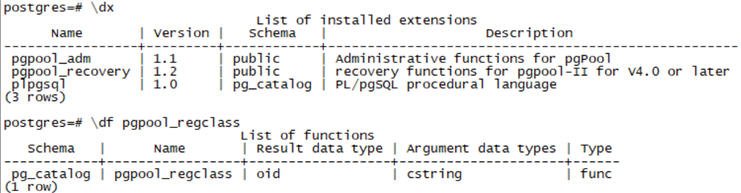

# Configure pgpool-II only for Load balance

## Copy template configuration

cd /opt/pgpool-II/etc

cp pool_hba.conf.sample pool_hba.conf

cp pcp.conf.sample pcp.conf

cp pgpool.conf.sample-stream pgpool.conf

# Working for Loadbalance only

# [pgpool.conf](https://docs.google.com/document/d/1CafYm8VKdectl_xXRqv1PRMfCUS8ZzE97TErGVYWbaM/edit)

### Key configuration for each node:

# watchdog hostname, local ip address

wd_hostname

# watchdog port default 9000, we define it to 60900

wd_port

# watchdog Weightiness, determine how much workload will this node taken.

wd_priority

# heartbeat hostname, remote node ip address.

heartbeat_destination0

# heartbeat port, remote node port.

heartbeat_destination_port0

# heartbeat device name

heartbeat_device0

# if there are more than 2 nodes

heartbeat_destination1

heartbeat_destination_port1

heartbeat_device1

# pgpool manage configuration

other_pgpool_hostname0

other_pgpool_port0

other_wd_port0

# [pcp.conf](https://docs.google.com/document/d/1SLM8K_lbjNVSPTYfbj4qufGw95-IO5nfyQM6f1vOs28/edit)

# store the password of pcp manager user,use following command-line to generate password and paste them inside pcp.conf

pg_md5 <password>

# [pool_hba.conf](https://docs.google.com/document/d/1YXzDsh2lOpmHNUEfyOFrAdUvrolrEZWWCt_n2xfKN_Y/edit)

# pool_hba.conf should configuration same as pg_hba.conf, if you need pgpool to manager the access policy.

<http://www.pgpool.net/docs/latest/en/html/auth-pool-hba-conf.html>

# pool_passwd

# add pgpool management password entry to allow pool access to pgs

<http://www.pgpool.net/docs/latest/en/html/auth-methods.html>

pg_md5 -p -m -u <User>

# Startup and shutdown the pgpool

pgpool -n -d > /opt/pgpool-II/logs/pgpool.log 2>&1 &

pgpool -m fast stop

# Reload configuration

pgpool reload

# verify pcp watch dog status

[root@pg-pgpool2-01 etc]# pcp_watchdog_info -h 10.6.35.100 -p 60898 -U repuser -v

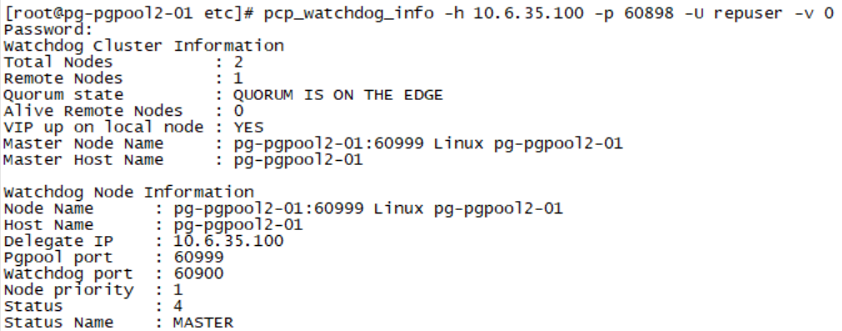

## 

## Configure nodes authorized access

vim /etc/hosts

10.6.35.6 pg-pgpool2-02

10.6.35.4 pg-pgpool2-01

# on each node

ssh-keygen -t rsa

# copy public key from 02 to 01 which allow 02 access 01 without password

[root@pg-pgpool2-02 .ssh]# ssh-copy-id -i ~/.ssh/id_rsa.pub root@pg-pgpool2-01

# Way 2 Paste the context of ~/.ssh/id_rsa.pub into ~/.ssh/authorized_keys on pg-pgpool2-01

# Verify the ssh connection

ssh pg-pgpool2-01

# Verify Load Balance Function

# Aim to confirm the result of LB

<http://www.pgpool.net/docs/latest/en/html/tutorial-testing-load-balance.html>

# create a database on primary database.

createdb -h10.6.35.4 -p60901 -Urepuser load_balance_node

# prepare the tables for LB test.

pgbench -i -s 100 -F 80 -h10.6.35.4 -p60999 -Urepuser -d load_balance_node

# launch simple query on pgpool connection.

pgbench -h10.x.x.100 -p60999 -Urepuser -c 20 -S -T 20 -P 10 load_balance_node

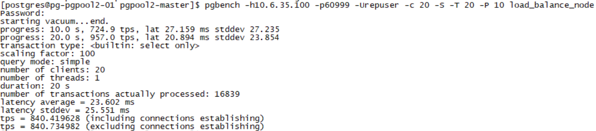

# Review result

Psql -h -p -U -c “show pool_nodes”



# Stop load balance

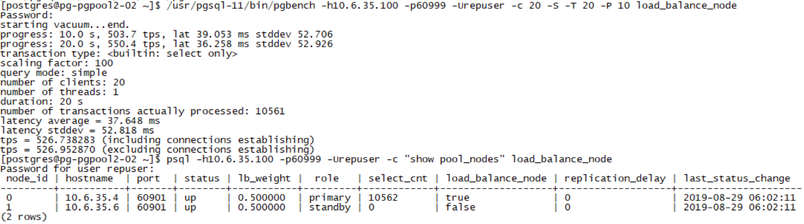

## Configure pgpool-II for Failover

### http://www.pgpool.net/docs/latest/en/html/runtime-config-failover.html

### Key configuration

# failover and failback scripts

failover_command = '/opt/pgpool-II/scripts/failover.sh 10.6.35.4'

failback_command = '/opt/pgpool-II/scripts/failback.sh 10.6.35.4'

# Verify Failover Function

# We can make primary node shutdown to pretend the database can not provide services, in the case, pgpool will automatically do failover.

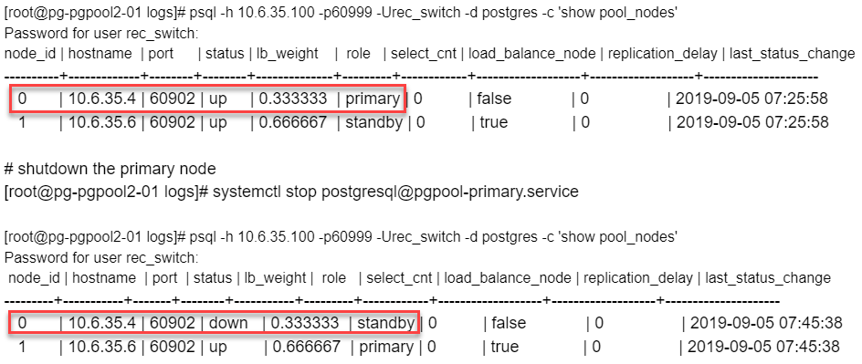

# Check pgpool processor

# pcp_proc_count -h 10.6.35.100 -p 60898 -Urepuser -v

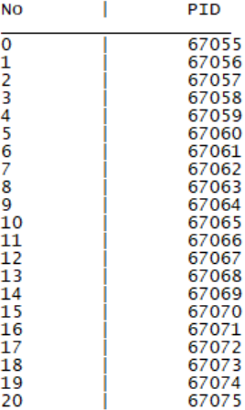

# Defect of PGPOOL

<https://blog.csdn.net/weixin_34268843/article/details/85511897>

SimpleQuery　→　pool_send_and_wait →　send_simplequery_message

/*

* Process Query('Q') message

* Query messages include an SQL string.

*/

POOL_STATUS SimpleQuery(POOL_CONNECTION *frontend,

POOL_CONNECTION_POOL *backend, int len, char *contents){

……

/* log query to log file if necessary */

if (pool_config->log_statement){

pool_log("statement: %s", contents);

}else{

pool_debug("statement2: %s", contents);

}

……

string = query_context->original_query;

if (!RAW_MODE){

……

/*

* Query is not commit/rollback

*/

if (!commit){

char *rewrite_query;

……

/*

* Optimization effort: If there's only one session, we do

* not need to wait for the master node's response, and

* could execute the query concurrently.

*/

if (pool_config->num_init_children == 1){

/* Send query to all DB nodes at once */

status = pool_send_and_wait(query_context, 0, 0);

/*

free_parser();

*/

return status;

}

/* Send the query to master node */

if (pool_send_and_wait(query_context, 1, MASTER_NODE_ID)

!= POOL_CONTINUE) {

free_parser();

return POOL_END;

}

}

/*

* Send the query to other than master node.

*/

if (pool_send_and_wait(query_context, -1, MASTER_NODE_ID)

!= POOL_CONTINUE{

free_parser();

return POOL_END;

}

……

}else{

……

}

return POOL_CONTINUE;

}

/*

* Send simple query and wait for response

* send_type:

* -1: do not send this node_id

* 0: send to all nodes

* >0: send to this node_id

*/

POOL_STATUS pool_send_and_wait(POOL_QUERY_CONTEXT *query_context,

int send_type, int node_id)

{

……

/* Send query */

for (i=0;i<NUM_BACKENDS;i++){

……

per_node_statement_log(backend, i, string);

if ( send_simplequery_message(CONNECTION(backend, i),

len, string, MAJOR(backend)) != POOL_CONTINUE) {

return POOL_END;

}

}

/* Wait for response */

for (i=0;i<NUM_BACKENDS;i++){

……

if (wait_for_query_response(frontend, CONNECTION(backend, i),

MAJOR(backend)) != POOL_CONTINUE){

/* Cancel current transaction */

CancelPacket cancel_packet;

cancel_packet.protoVersion = htonl(PROTO_CANCEL);

cancel_packet.pid = MASTER_CONNECTION(backend)->pid;

cancel_packet.key= MASTER_CONNECTION(backend)->key;

cancel_request(&cancel_packet);

return POOL_END;

}

……

}

return POOL_CONTINUE;

}

经过对程序的进一步分析和试验，可以得出以下的结论：

在 Master Node 和其他各Node之间，对SQL文的执行是串行的。

在 Master Node以外的其他各Node之间，是并行执行的。其实是

/* Send query */ 一段，无阻塞方式向各节点发送SQL文。

/* Wait for response */ 一段，虽然也是个循环，但是是串行。

不过好在向各节点发SQL文的时候，几乎是同时地发送命令，

所以 Wait for response 对一个节点检查获得SQL文执行结束消息以后，

几乎同时也会获得下一个节点SQL文执行结束的消息。

综合以上：如果对一个节点单独执行一段批处理耗时1小时，那么在replication mode 多个节点运行条件下，执行时间将变成 2小时。

至于为何 pgpool-II把对 Master Node和 其他Node的执行分开，也许有特殊考虑，也许是为了保证Master Node的正确性。